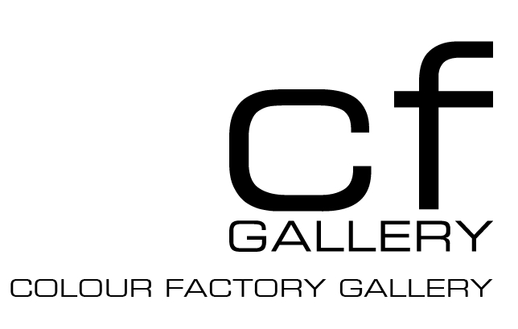

Colour Factory Photographic Award 2012
Colour Factory is calling out for entries in the new annual Colour Factory Photographic Award. We encourage early career artists to participate in the opportunity of winning a solo exhibition at CF Gallery from 6th December 2012 – 26th January 2013. The prize covers all expenses of the gallery and includes fine art photographic printing (not framing).
The term photographic refers to the process of printing chromogenic ‘C-type’ prints. The submitted images must be made in camera. Photographers are invited to submit 5 A4 printed images from a series of work created within the last two years. Up to 10 images may be submitted, the remaining images are accepted as files. Entries submitted as files only are ineligible for the prize. The wining work will be a technically and conceptually strong, cohesive body of work.
Entries close: Monday 15 October
Winner announced: Monday 12 November
Exhibition dates: 6 December–26 January 2013

JUDGES
Penny Harris Contemporary Art Collector
Lisa Fehily Director, Fehily Contemporary
Polixeni Papapetrou Photographic Artist

Terms and conditions of entry
Eligibility
- Entries will be considered from still photo based media including analogue and digital photography. The work must be captured ‘in camera’ to be eligible.
- Works must have been produced since October 2010.
- Works must not have been exhibited before with the exception of student exhibitions or individual works in competitions.
- Entrants must be an Australian citizen or hold a permanent resident visa or a current student visa.
- Relatives, employees and board members of Colour Factory and the judging panel are not permitted to enter.
- The award aims to provide an opportunity to early career artists working with photography. Generally, early career refers to artists who have not held a solo exhibition at a commercial gallery.
- Students may enter the award.

Entry requirements
- Entries close on Monday 15th October 2012.
- The selection is judged from hard copy. Entry is a minimum of 5 printed photographs, C-type or inkjet; 8 x 10 inch/ A4 size with artist’s name and image number on the back. A maximum additional 5 images from the series may be included on disc to exemplify the exhibition in its entirety. Maximum file size of additional images is 3mg per file, saved as jpegs, with artist last name_artist first name_image number. Eg. Smith_Jane_1. We will not be accepting photocopied productions, emailed images or slides.
- A completed entry form in hard copy.
- An artist's statement (300 words maximum).
- Information on how the work will be installed in the gallery; approximate size and number of images (300 words maximum).
- An artist's curriculum vitae (1 page maximum).
- An entry fee of $20 (note that entries are GST-free). Entrants may submit one entry. The entry fee is non-refundable and covers administration and handling. Any entry not accompanied with payment of the entry fee will be deemed ineligible. Photographs will not be returned unless supplied with a prepaid envelope. Entrants may collect the work from Colour Factory after Monday November 12; all uncollected work will be disposed of by November 30. Payment of the entry fee may be made by credit card (Visa or MasterCard only). Cash/money order and cheque payments will be accepted. Receipts will be mailed. Entries must be addressed to: Colour Factory Photographic Award 2012, Colour Factory, 409 – 429 Gore Street, Fitzroy, 3065, Melbourne, Victoria, Australia.
- Emailed entries will not be accepted.
Exhibition and judging
- The judges will award the prize of free printing and an exhibition at CF Gallery for the winning work.
- The winning work will be exhibited from 6 December–26 January 2013.
- All entries accepted for exhibition must be available for continuous display at CF Gallery throughout the period of the exhibition.
- The selected works will be available for sale throughout the exhibition, and our standard gallery commission rate applies to all sales.
- The judges' decision will be final and no correspondence will be entered into.
- All entrants will be notified of the result via email by Monday 12 November 2012.
Promotion
- The entrant agrees to CF Gallery reproducing the entered work in all publicity and promotion of the Colour Factory Photographic Award 2012 subject to Colour Factory’s discretion. All credit will be given to the Artist.
- The entrant agrees to participate in media interviews if required.
Information
- All personal information gathered by CF Gallery will be used solely for the purpose of administering the Colour Factory Photographic Award 2012.

For further enquiries please email: mail@colourfactory.com.au or call us on +61 3 9419 8756

ENTRY FORM
Please include this page and the following three pages with your entry. Your entry must be delivered or posted to Colour Factory. Colour Factory will not accept applications via email.

Personal information
Name:
AddresS:
 | Suburb
state
Postcode | Country
TELEPHONE:
Home | Work
Mobile
email:

PAYMENT
I wish to enter the Colour Factory Photographic Award 2012 and agree to abide by the conditions outlined
$20 Entry
I am paying by
Cash
Cheque, made payable to Colour Factory
Credit card Please charge my MC VISA $__________
Card Holder Name:
Card Number: | EXP:

Prices are inclusive of GST. Please post your entry form, payment and support material to:
Colour Factory Photographic Award 2012, Colour Factory, 409 – 429 Gore Street, Fitzroy VIC 3065

ARTIST STATEMENT
About the series, including information about the techniques used to produce the work.
MAX 300 WORDS
PHYSICAL DESCRIPTION
What will physically be in CF Gallery? Specify number of works; desired exhibition print size; method of installation ie: framed, mounted, pinned etc
MAX 300 WORDS

CURRICULUM VITAE
Please copy your curriculum vitae in the box below.

LIst OF Works
Please provide a minimum of 5 printed images with your application. You may submit either:
10”x 8” or A4 work prints along with a CD with up to 5 additional images from the body of work.
If you are printing from digital files you must state the final print resolution (dpi) and file size (MB)

# | Title of Work | year | Print TYpe  (ie: C-type print) | FINAL PRINT  dimensions  (h x w) | Final PRINT  Resolution  (Please state dpi and file size (MB)
1
2
3
4
5
6
7
8
9
10

termS and conditions CHECKLIST
- I am an early career artist
- My proposed work has not been previously exhibited and if selected will not be exhibited prior to the Colour Factory Award exhibition
- The work was made in camera

APPLICANT DECLARATION
- I, the undersigned, have read and completed all the information required entry to the
Colour Factory Photographic Award 2012.
- I have read & completed all pages, as well as including work prints and a stamped, self-addressed envelope (if I wish my entry to be returned).

Signature x
Date

